James Turrell
Resources
Videos
Introduction to James Turrell 4:19 minutes Guggenheim
https://www.youtube.com/watch?v=udlzm3Ea3RE
James Turrell, Skyscape, The Way of Color 4:40 minutes Crystal Bridges Museum of American Art
Bentonville, Arkansas
https://www.youtube.com/watch?v=akKpEgoMeNY
James Turrell’s Roden Crater 8:14 minutes Los Angeles County Museum of Art
https://www.youtube.com/watch?v=g0g6JFYRKxQ
Websites/Articles
https://jamesturrell.com/
https://moody.rice.edu/james-turrell-twilight-epiphany-skyspace
https://massmoca.org/event/james-turrell/
https://www.smithsonianmag.com/arts-culture/james-turrell-visionary-artwork-arizona-desert-
180977452/
Additional Resources
James Turrell 8:31 minutes Guggenheim
https://www.youtube.com/watch?v=MVoMJHSNyI0
James Turrell X Kayne West An Artist Talk by Nimea Ariana 9:43 minutes
https://www.youtube.com/watch?v=l-7CweovQrM
The Turrell skyscape at Rice University 4:45 minutes
https://www.youtube.com/watch?v=GrD5ylEn1wQ
Websites
https://en.wikipedia.org/wiki/James_Turrell
https://www.pacegallery.com/exhibitions/james-turrell-9/
https://www.architecturaldigest.com/story/james-turrell-art-around-the-world
https://www.keranews.org/arts-culture/2023-02-16/internationally-renowned-american-artist-james-
turrell-adds-fort-worth-project-to-his-portfolio
https://www.architecturaldigest.com/story/james-turrell-art-around-the-world
https://www.theartstory.org/artist/turrell-james/
https://www.thrillist.com/travel/nation/what-is-the-roden-crater
https://news.asu.edu/20190114-creativity-asu-artist-james-turrell-partner-masterwork-roden-crater
https://www.pbs.org/video/james-turrell-green-mountain-falls-skyspace-jczdau/

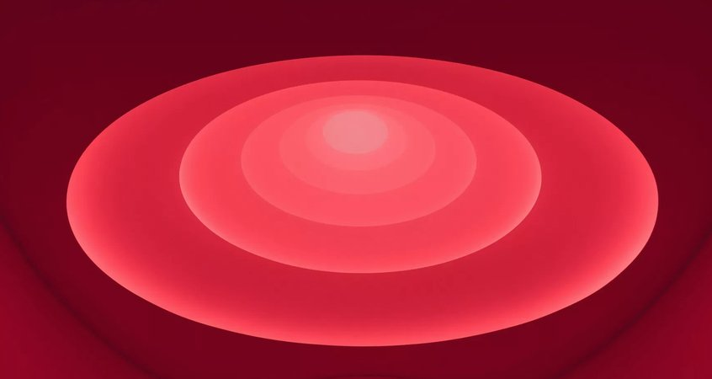
1 Sustaining Light
2Aten Reign
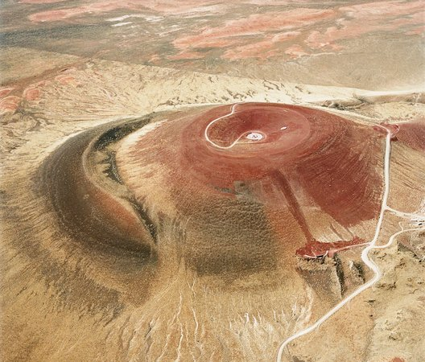
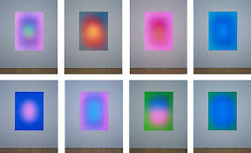
3 Roden Crater

