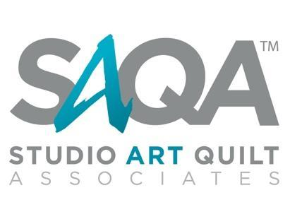

JUROR AGREEMENT

Title of Exhibition

Studio Art Quilt Associates, Inc. (“SAQA”), wishes to engage ______ (“Juror”), to act as sole juror for the exhibition entitled ________ (“Exhibit”), and the Juror wishes to accept this engagement.

THEREFORE, SAQA and the Juror agree as follows:

1. SAQA will:
- Provide to the Juror a copy of the prospectus/call for entry for the Exhibit;
- Notify the Juror of the number of pieces to be selected and/or provide additional information regarding the hanging space;
- Provide training for the Juror on the use of the online entry system, including a link for access to the system;
- Supply to the Juror images of works entered in the Exhibit, together with artist statements and other information necessary for the selecting pieces, on or before _______
- Be available during the jury process to answer questions and/or provide assistance to the Juror.

2. The Juror will:
- Coordinate with SAQA for training on the use of the online entry system;
- Complete the selection of pieces on or before ________ and will notify SAQA by email when the selection process has been completed.
- Prepare and deliver an essay concerning the Exhibit and selected pieces as directed by SAQA (the “Essay”) to SAQA on or before __________.
3. Upon satisfactory completion of the selection process described above, and timely receipt of the Juror’s essay (if applicable), SAQA will pay to Juror a fee of USD $_________.
The contact for the Exhibit is:

Name:
Email:
Phone:

In consideration of the foregoing agreements, SAQA and the Juror have executed this Agreement on the dates indicated below.

Studio Art Quilt Associates, Inc.

By: ___________________________ Dated:

Its:

Juror:

_________________________________ Dated:
Name

Contact information for Juror:
Email:
Phone:
Address:

