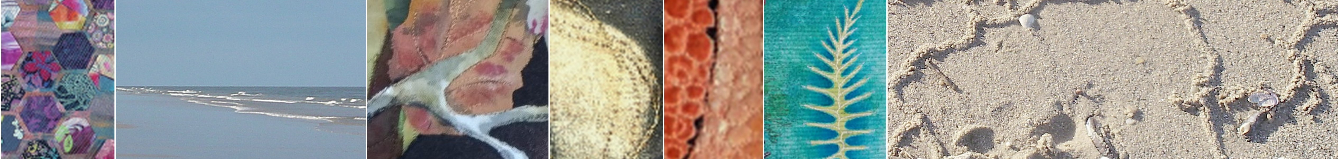
Oceania: Distance and Diversity
SAQA Oceania exhibition
ENTRY FORM

First name: Click here to enter text.
Last name: Click here to enter text.
Address: Click here to enter text.

Phone number (include country code)
Home: Click here to enter text.
Mobile: Click here to enter text.

Email: Click here to enter text.
Artist’s website (if applicable): Click here to enter text.

Title of art work: Click here to enter text.

Artist’s statement (not to exceed 150 words)
Click here to enter text.

Materials and techniques used (not to exceed 75 words)
Click here to enter text.

Date of completion: Click here to enter text.
Photographer: Click here to enter text.
Is your art quilt for sale? ☐Yes ☐ No
If yes, please specify price as $A or $NZ: click here to enter text.
If no, please provide artist’s stated value: Click here to enter text.
*The artist’s stated value is the value of the artwork determined by the artist which represents the dollar amount (in the currency of the artist’s country) the work would be priced if it was for sale. Do not deduct any amount for anticipated commission when determining this value.
Submit two correctly labelled digital images. One FULL digital image and one DETAILED digital image of your submitted piece of artwork. Please see the Call for Entry for important details on acceptable digital images.
Label each image with your surname followed by the initial of your first name and the first 1-3 words of the art work’s title followed by whether it is a full image or a detailed image, e.g. BrownBGolddustFull.jpg and BrownBGolddustDetail.jpg. Identification of images will be removed before selection by jurors to maintain the integrity of the jury process.
DECLARATION
- I certify that the art work submitted is designed and created solely by me.

- I agree to loan my art quilt to Studio Art Quilt Associates Oceania Region. I understand that the cost of insuring and shipping my artwork to and from designated shipping points is my responsibility

- I agree to permit images of my accepted work to be used in publicity, in any media format, associated with the promotion of the exhibition.

- I understand that any artwork that differs from the submitted images may be disqualified

- I certify that to the best of my knowledge, this artwork does not violate any current copyright and trademark laws

- I agree that my artwork cannot be removed prior to the end of the travelling exhibition period.

Signature Click here to enter text. Date Click here to enter text.
Please attach this completed entry form and your two digital images and email it to:

saqaoceania@gmail.com

Any questions? Please contact:

Julia Arden(Curator): julia.arden@xtra.co.nz

Lois Parish Evans (Exhibition Coordinator & Oceania Rep): loisparishevans@gmail.com
Carol Croce (Oceania Rep): croceau@gmail.com

